Name = U.Siddhartha

Roll No = 2403A54122

Batch = 18

Set = A

Question No- 01

Write a Python code to calculate the sum of odd and even numbers in a given list using GitHub Copilot along with VS Code. Use zero shot prompting

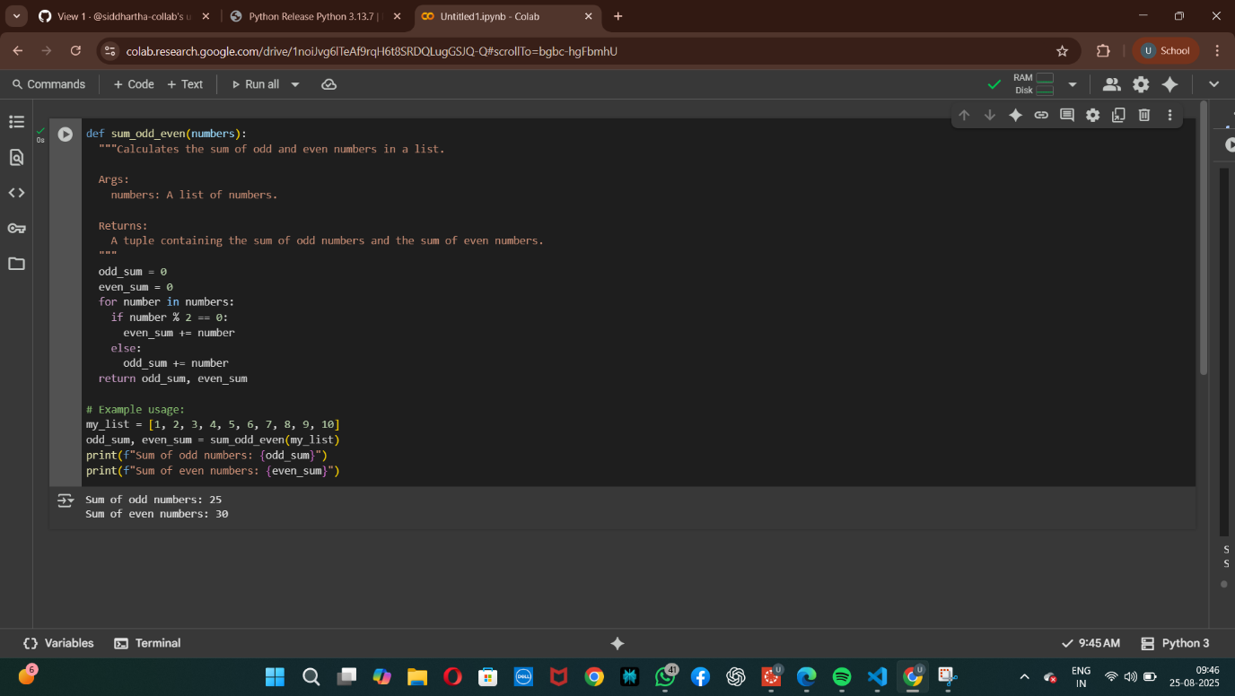

Question No – 02

Write a Python code for given a list of integers, remove duplicates and print the sorted result. GitHub Copilot along with VS Code. Use one shot prompting.

